1.

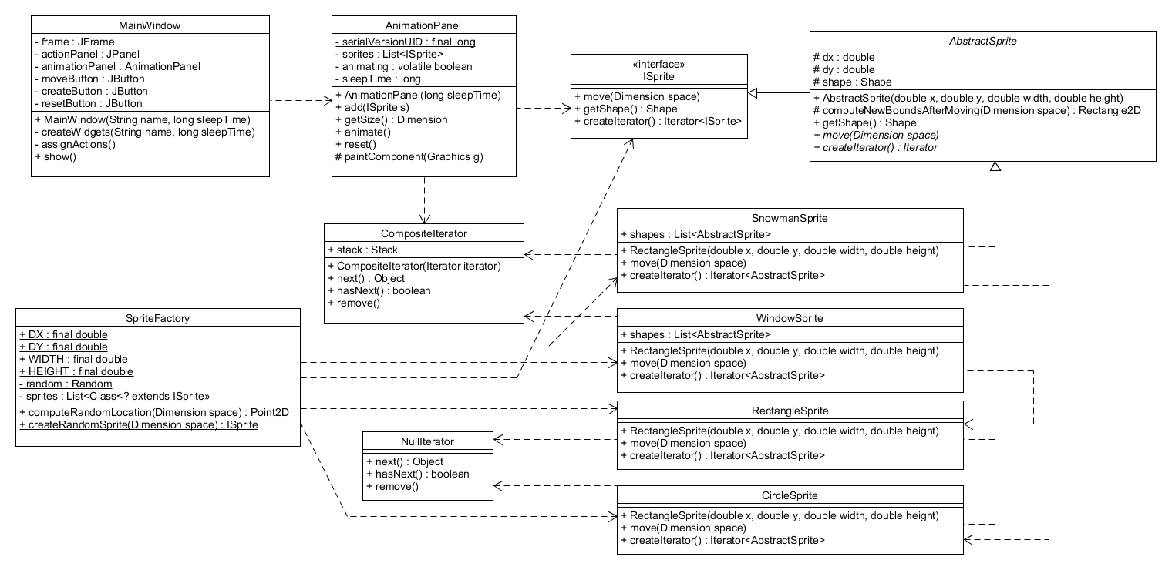

This design implements the Composite pattern, utilizing a Composite Iterator to handle the Sprites with children. The Sprites with children are the SnowmanSprite and WindowSprite which use 3 CircleSprites and 3 RectangleSprites, respectively. The Sprites without children are the CircleSprite and RectangleSprite which utilize a NullIterator because they are leaves. The AnimationPanel handles all of the movement and drawing of the Sprites.

3.

The SnowmanSprite will appear upright until it hits the top border and upside down until it hits the bottom border.

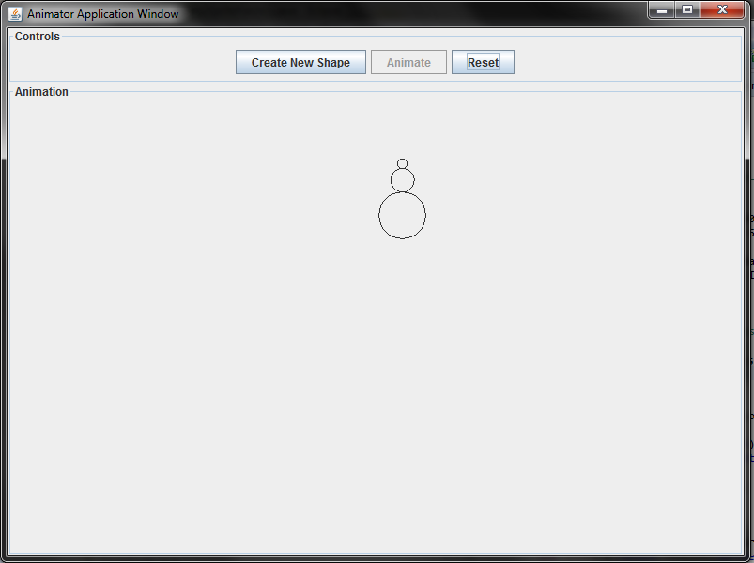

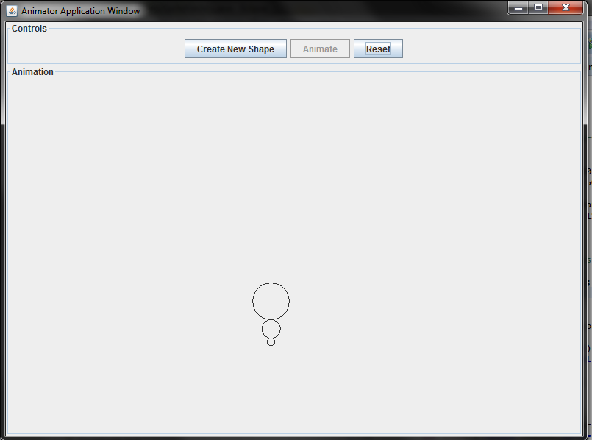

The WindowSprite maintains the same appearance while it moves.

